🔹 What is a Method in Java?
A method is a block of code that performs a specific task.
Instead of writing the same code again and again, we put it inside a method and reuse it.
👉 Method = Named behavior

🔹 Parts of a Method (Corrected & Complete)
A Java method actually has 6 important parts, not just 4.

✅ Correct List of Method Parts
- Access Modifier (missing point)
- Return Type
- Method Name
- Input Parameters
- Method Body
- Return Statement (optional, depends on return type)
Let us understand each one clearly.

1️⃣ Access Modifier (❗ Missing Point)

🔹 What is it?
It defines who can call the method.

🔹 Common Access Modifiers
- public → accessible everywhere
- private → accessible only inside the same class
- protected → accessible within package + subclasses
- default (no keyword) → package level

🔹 Syntax position
accessModifier returnType methodName(parameters)

🔹 Example
public void display() {
}

2️⃣ Return Type

🔹 What is it?
Return type tells:
What type of value the method sends back to the caller

🔹 Common return types
- int, double, boolean, String
- Object
- void → returns nothing

🔹 Important Rules
- If return type is not void, method must return a value
- Returned value must match the return type

🔹 Example
int add(int a, int b) {
return a + b;
}
void printMessage() {
System.out.println("Hello");
}

3️⃣ Method Name

🔹 What is it?
- The identifier used to call the method
- Represents what the method does

🔹 Naming Rules
- Must be a valid Java identifier
- Should start with lowercase
- Use camelCase

🔹 Examples
calculateTotal()
getStudentName()
printDetails()

4️⃣ Input (Parameters)

🔹 What are parameters?
Parameters are inputs given to the method to work with.

🔹 Points to remember
- Parameters are local variables
- They exist only inside the method
- Multiple parameters allowed
- Can be zero parameters also

🔹 Syntax
methodName(dataType param1, dataType param2)

🔹 Example
int multiply(int x, int y) {
return x * y;
}
void greet() {
System.out.println("Welcome");
}

5️⃣ Method Body

🔹 What is it?
- The actual logic
- Written inside { }
- Executes when the method is called

🔹 Contains
- Statements
- Calculations
- Conditions
- Loops
- Method calls

🔹 Example
void show() {
System.out.println("Inside method");
}

6️⃣ Return Statement (Conditional Part)

🔹 What is it?
- Sends the result back to the caller
- Ends method execution immediately

🔹 Rules
- Mandatory for non-void methods
- Optional for void methods
- Must return compatible data type

🔹 Example
int square(int n) {
return n * n;
}
void stop() {
return; // optional
}

🔹 Complete Method Syntax (Final)
accessModifier returnType methodName(parameterList) {
// method body
return value; // only if return type is not void
}

🔹 Full Example (All Parts Together)
public int add(int a, int b) {
int sum = a + b;
return sum;
}

Breakdown:
- public → access modifier
- int → return type
- add → method name
- int a, int b → parameters
- { ... } → method body
- return sum; → return statement

🔑 One-Line Interview Gold Answer
👉 A method in Java consists of an access modifier, return type, method name, parameters, method body, and an optional return statement that sends a value back to the caller.

🧠 Now Let’s Walk the Exact JVM Flow (Step-by-Step)
This section explains how a Java program actually runs inside the JVM, step by step, in the exact order.

Step 1️⃣ Compilation (Already Clear)
- You write Java source code in a .java file.
- The Java compiler (javac) converts this source code into a .class file.
- This .class file contains bytecode, which is a set of instructions understood by the JVM.
After compilation:
- Bytecode is stored in the Method Area of JVM memory.
- The Method Area works like a storage place for program instructions.
📌 At this point:
- No method is running
- Stack is empty
- Only instructions are stored, nothing is executed yet

Step 2️⃣ Program Starts → Thread Created
- When you run the program, the JVM starts execution.
- JVM creates a main thread.
- Every thread has:
  - its own runtime stack (used during execution)
  - its own PC (Program Counter) register
At this stage:
- Stack exists, but no stack frame is created yet
- JVM is ready to start executing methods

Step 3️⃣ JVM Wants to Execute main()
This is the most important step.

❓ What happens to main() bytecode now?
Here is the exact JVM behavior:
- JVM finds the main() method’s bytecode inside the Method Area
- JVM creates a new stack frame for the main() method
- This stack frame is created only to support execution, not to store code
- JVM sets the PC register to point to:
  - the first bytecode instruction of main() in the Method Area
📌 Very important:
- No bytecode is copied
- No bytecode is moved
- Only an instruction address is used

🔑 CRITICAL CONCEPT: PC Register (This Solves Everything)
The PC Register plays a key role in execution.
It:
- Stores the address of the next instruction to run
- Always points inside the Method Area, where bytecode is stored
So execution works like this:
PC → Method Area (instruction)
↓
instruction is executed using Stack Frame
↓
PC moves to next instruction
📌 The PC keeps moving forward,
📌 The bytecode stays in the same place.

🧠 Think of It Like This (Perfect Analogy)
- Method Area → Library 📚
- Bytecode → Pages of the book
- PC Register → Bookmark 🔖
- Stack Frame → Writing desk ✍️
You:
- read the book from the library
- use the desk to work and write
- never bring the whole book to the desk

🔄 Execution Cycle (Very Important)
For each instruction, the JVM does the following:
- PC points to one bytecode instruction in the Method Area
- JVM reads (fetches) that instruction
- JVM executes it using the stack frame:
  - local variables are read or updated
  - calculations are done
  - temporary values are stored
- PC moves to the next instruction
This cycle continues until the method finishes.

📌 What Happens When Another Method Is Called?
Example:
main() {
show();
}
During execution:
- JVM reaches the instruction that calls show()
- JVM pauses execution of main()
- JVM creates a new stack frame for show()
- PC is updated to point to:
  - the first instruction of show() in the Method Area
- show() method starts executing in the same way
📌 Again:
- Bytecode is not copied
- Bytecode is not moved
- Only execution context changes

🧾 After Method Finishes
When a method completes:
- Its stack frame is removed (popped) from the stack
- PC is restored to the instruction after the method call
- Execution continues in the calling method
- Bytecode remains safely stored in the Method Area

✅ Final, Perfect Answer (Memorize This)
👉 The JVM never copies or moves bytecode into the stack.
Bytecode always stays in the Method Area, and the JVM executes it by reading instructions using the PC register and using stack frames to perform the work.

🏆 One-Line Gold Rule
👉 Stack frames are used for execution, bytecode is only read, never moved.

Note:
Java source code is compiled into bytecode and stored in the Method Area. When a method is invoked, the JVM creates a stack frame for that method and executes its bytecode instructions using that frame. After execution completes, the stack frame is removed.
👉 Diagrams often show source code inside stack frames for conceptual understanding, but in reality bytecode instructions remain in the Method Area. When the main method is invoked, the JVM creates a stack frame for it and executes its bytecode instructions by fetching them from the Method Area. After execution completes, the stack frame is popped (removed).

class Employee {
String name = "Raju"; // Instance Variable (Heap)
}

public class MemoryTest {

// Execution starts here
public static void main(String[] args) {
int x = 10; // Local Primitive (Stack - Main Frame)
Employee e = new Employee(); // Reference Variable (Stack) -> Object (Heap)

m1(); // Calling m1() pushes a NEW frame onto the Stack
}

public static void m1() {
int y = 20; // Local Primitive (Stack - m1 Frame)
// When m1 finishes, this frame is destroyed (popped)
}
}
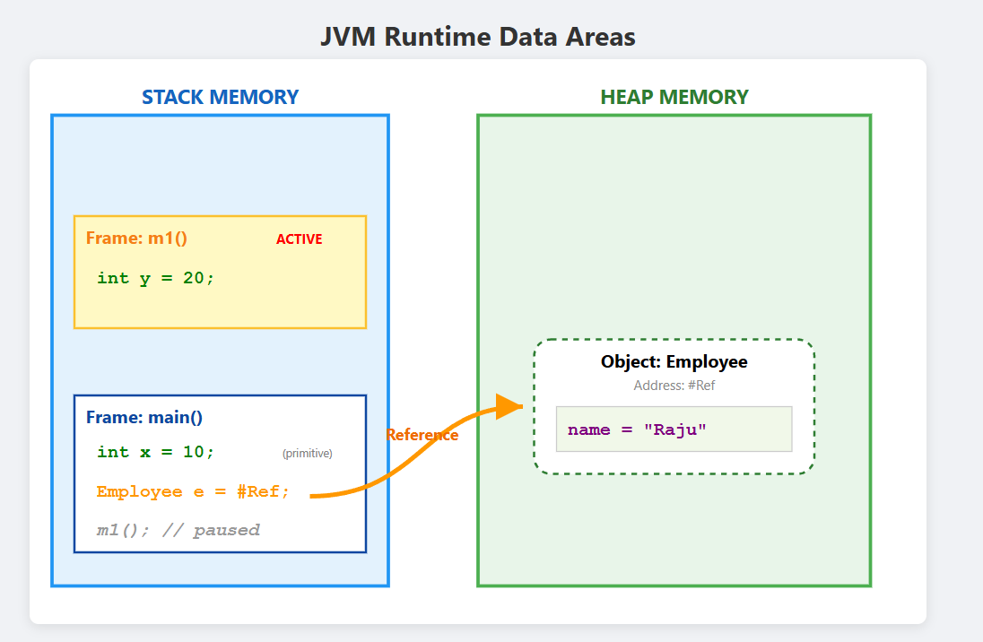

Note:

🔹 Return Value Note
If a method has a return type other than void, it returns a value to the caller.
It is optional for the caller to store or use that returned value.
✔️ The method must return a value
✔️ The caller may ignore it
Example:
int add(int a, int b) {
return a + b;
}

add(10, 20); // return value ignored
int x = add(10, 20); // return value collected

🔹 Parameters Note
If a method is declared with parameters, then arguments must be passed while calling the method.
- Number of arguments must match
- Data types must match
- Order must match
Example:
void show(int x) { }

show(10); // ✔️ correct
show(); // ❌ error

🏆 One-Line Summary (Gold)
👉 Returned values may be ignored by the caller, but parameters declared in a method must always receive matching arguments during the method call.

Eg: Method_With_Return_Type_And_Parameters

Note: Inside a method, we can write a lambda expression.

🔹 Lambda Expression (Short Note)
A lambda expression is a short and anonymous block of code introduced in Java 8.
It is used to provide an implementation for a functional interface (an interface with exactly one abstract method).
A lambda expression:
- Has no name
- Is not a method
- Can be written inside a method
- Helps write code in a shorter and clearer way
It represents behavior (logic) that can be passed as data and executed later.

🔹 Syntax
(parameters) -> {
// logic
}

🔹 Example
Runnable r = () -> {
System.out.println("Hello Lambda");
};

🔑 One-Line Summary
👉 A lambda expression is an anonymous function-like expression used to implement a functional interface, not a nested method.
👉 A method inside another method is NOT allowed in Java — ever.

❌ Example (NOT allowed in Java)
void outer() {
void inner() { // ❌ Compilation Error
System.out.println("Hello");
}
}
👉 This code never compiled, in any Java version.

🔍 Then Where Did the Confusion Come From?

Because of Lambda Expressions (Java 8)
Java 8 introduced lambda expressions, which:
- Look like small functions
- Can be written inside methods
- But are NOT methods

🧠 What Lambda Expressions REALLY Are
A lambda expression is:
- An anonymous implementation
- Of a functional interface
- Written inside a method
👉 It is not a nested method.

✅ Example: Lambda (Allowed)
Runnable r = () -> {
System.out.println("Hello");
};
✔️ This is valid
❌ But this is not a method declaration

✅ Simple Example (Inside a Method)
void test() {

Runnable r = () -> {
System.out.println("Hello from lambda");
};

r.run();
}
✔️ Lambda written inside a method
✔️ No nested method
✔️ Completely valid

❌ What Is NOT Allowed
void test() {

void inner() { // ❌ NOT allowed
System.out.println("Hello");
}
}
❌ This is a nested method
❌ Java does not allow this

